**APEX COLLEGE**

**POKHARA UNIVERSITY**

**LAB REPORT OF**

**DOT NET TECHNOLOGY**

**LAB -1**

**Submitted By: Submitted To:**

**Remisha Maharjan Bishwomitra Adhikari**

**BCIS ‘Adware’ Ananta Pant**

**Roll no: 17**

**OBJECTIVE:-**

TO GET FAMILIAR USING MVC

1.Make a model

**Person.cs**

**using System;**

**namespace lab1_mvc.Models**

**{**

**public class Person**

**{**

**public string Name { get; set; }**

**public string Address{get;set;}**

**}**

**}**

2. In controller make an object to display your name and address.

**HomeController.cs**

**using System;**

**using System.Collections.Generic;**

**using System.Diagnostics;**

**using System.Linq;**

**using System.Threading.Tasks;**

**using Microsoft.AspNetCore.Mvc;**

**using lab1_mvc.Models;**

**namespace lab1_mvc.Controllers**

**{**

**public class HomeController : Controller**

**{**

**public IActionResult Index()**

**{**

**var model=new Person();**

**model.Name="Remisha";**

**model.Address="Rabi Bhawan";**

**// ViewBag.Name=model.Name;**

**// ViewBag.Address=model.Address;**

**return View(model);**

**}**

**public IActionResult Privacy()**

**{**

**return View();**

**}**

**[ResponseCache(Duration = 0, Location = ResponseCacheLocation.None, NoStore = true)]**

**public IActionResult Error()**

**{**

**return View(new ErrorViewModel { RequestId = Activity.Current?.Id ?? HttpContext.TraceIdentifier });**

**}**

**}**

**}**

3. Showing the output in the view

**Index.cshtml**

**@model lab1_mvc.Models.Person**

**@{**

**ViewData["Title"] = "Home Page";**

**}**

**<div class="text-center">**

**<h1 class="display-4">Welcome</h1>**

**<p>Learn about <a href="https://docs.microsoft.com/aspnet/core">building Web apps with ASP.NET Core</a>.</p>**

**</div>**

**<p>@Model.Name</p>**

**<p>@Model.Address</p>**

**@* <p>**

**Name:@ViewBag.Name**

**Address:@ViewBag.Address**

**</p> *@**

**OUTPUT:**

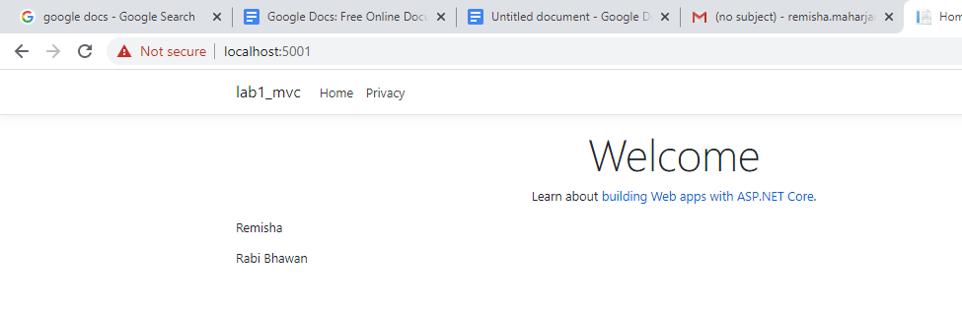

**CONCLUSION**

In lab1, we learned the basic way of using MVC in dot net technology.